SIMATS ENGINEERING
Department of Computer Science & Engineering
ASSESSMENT TOOL 2- DEBUGGING & OPTIMISATION TASK

Course Code: | CSA1205 | Course Title: | Computer Architecture for Multicore Systems
CO Assessed: | CO2 | Assessment: | ASSESSMENT TOOL2- DEBUGGING & OPTIMISATION TASK
Weightage: | 20% | Total Marks: | 25
CO2 Statement: | Apply integer and floating-point arithmetic algorithms including Booth's multiplication, restoring/non-restoring division, and IEEE 754 standard operations to solve fixed-point and floating-point computational problems. (BL3)
Student Name: | D. Gnana Deepthi | Reg.No.: | 192411123
Department: | CSE | Date: | 08-08-2026

ANNEXURE A
- A program performing signed integer addition using 2’s complement produces incorrect results when adding large values (e.g., +120 and +50 in 8-bit representation). Debug the issue by analyzing the binary computation and identifying whether overflow has occurred. Propose a solution to correctly detect and handle overflow in such cases.
- A processor using a ripple carry adder shows significant delay in executing arithmetic operations in a real-time system. Debug the performance bottleneck by examining how carry propagates through each bit. Suggest an optimized solution using a carry look-ahead adder, and explain how it reduces delay.
- A multiplication unit implementing Booth’s algorithm gives incorrect results for certain negative operands. Debug the step-by-step execution of the algorithm, focusing on bit-pair checking, arithmetic shifts, and sign extension. Identify the possible source of error and suggest corrections to ensure accurate signed multiplication.
- An embedded system using the restoring division algorithm experiences inefficiency due to repeated restoration steps, leading to increased execution time. Debug the algorithm’s workflow and identify where unnecessary operations occur. Propose an optimized approach using the non-restoring division method, explaining how it improves performance.
- A scientific application using IEEE 754 single precision floating-point representation produces inaccurate results when adding very small and very large numbers. Debug the issue by analyzing exponent alignment, normalization, and rounding errors. Suggest optimization techniques, such as using double precision or algorithmic adjustments, to improve accuracy.

Code of Conduct:

I D. Gnana Deepthi (192411123) (Name / Reg No) certify that this submission is my original work and that I have adhered to the guidelines specified for this assessment.I understand that any violation of academic integrity rules will result in disciplinary action.

Signature of the student:


ANSWERS

1.
1. PROBLEM STATEMENT
A program performing signed integer addition using 2’s complement produces an incorrect result when adding large values such as +120 and +50 in 8-bit representation. The problem is to analyze the binary addition, identify whether overflow has occurred, and propose a method to correctly detect and handle the overflow.
2. ANALYSIS
In an 8-bit signed 2’s complement representation, the range of values is:
-128 to +127
The binary representation of the given numbers is:
- +120 = 01111000
- +50 = 00110010
Performing binary addition:
01111000 (+120)
+ 00110010 (+50)
------------
10101010
The result is 10101010.
Since the most significant bit is 1, the result is interpreted as a negative number in 2’s complement.
To find its decimal value:
10101010
Invert → 01010101
Add 1 → 01010110
01010110 = 86
Therefore:
10101010 = -86
However, the actual mathematical result is:
120 + 50 = 170
The value 170 is outside the 8-bit signed range of -128 to +127.
3. OVERFLOW DETECTION
Overflow has occurred because two positive numbers were added but the result became negative.
The general rule for detecting signed overflow is:
If A and B have the same sign
and the result has a different sign,
then overflow has occurred.
For this example:
A = Positive
B = Positive
Result = Negative
Therefore, overflow = TRUE.
4. SOLUTION
The problem occurs because an 8-bit signed 2's complement number can represent values only from -128 to +127.
For the given values:
+120 = 01111000
+50 = 00110010
Binary addition:
01111000
+ 00110010
----------
10101010
The mathematical result is:
120 + 50 = 170
But 170 is greater than 127, so it cannot be represented in 8-bit signed 2's complement. The binary result 10101010 represents -86, which is an overflow condition.
The overflow can be detected by checking whether the result is outside the range -128 to +127.
5. CODE:
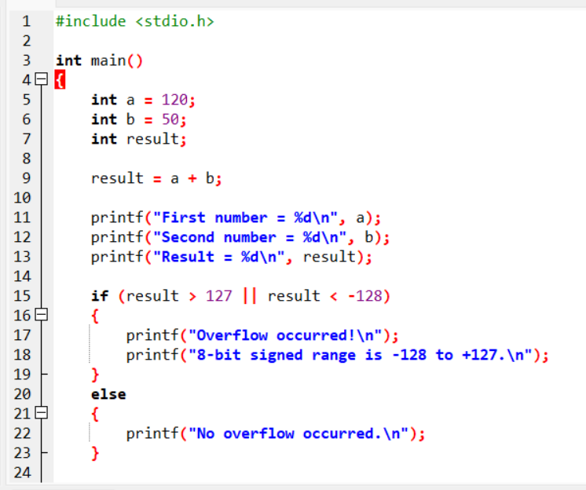

OUTPUT:
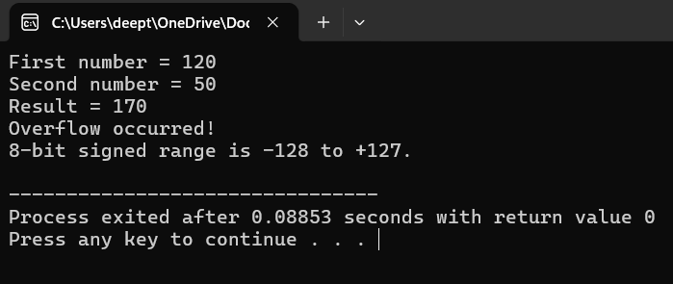

6. CONCLUSION
The addition of +120 and +50 results mathematically in 170, but 170 cannot be represented using an 8-bit signed 2’s complement number. The binary result 10101010 is interpreted as -86, indicating signed integer overflow. The program should detect the overflow using sign-bit checking or by performing the calculation with a larger data type before storing the result.

2.
1. PROBLEM STATEMENT
A processor using a Ripple Carry Adder (RCA) experiences significant delay during arithmetic operations in a real-time system. The delay occurs because the carry generated at one bit must propagate through all the subsequent bits before the final result can be obtained. The problem can be solved by using a Carry Look-Ahead Adder (CLA), which calculates carry signals in advance and reduces the overall addition delay.
2. ANALYSIS OF RIPPLE CARRY ADDER
In a Ripple Carry Adder, each full adder waits for the carry output from the previous stage.
For a 4-bit addition:
A3 B3 A2 B2 A1 B1 A0 B0
| | | | | | | |
[FA3] ← [FA2] ← [FA1] ← [FA0]
C3 ← C2 ← C1 ← C0
The carry propagates sequentially:
C0 → C1 → C2 → C3 → C4
Therefore, the carry generated by the least significant bit must pass through each full adder before the final carry is available.
For an n-bit ripple carry adder, the worst-case delay increases approximately linearly with the number of bits:
Delay ≈ O(n)
This becomes a performance bottleneck in real-time systems because the processor may have to wait for the carry to ripple through many stages.
3. EXAMPLE OF CARRY PROPAGATION
Consider:
1111
+ 0001
------
10000
The carry must propagate through every bit:
Bit 0 → Bit 1 → Bit 2 → Bit 3 → Final Carry
Thus, each stage waits for the previous stage.
4. OPTIMIZED SOLUTION: CARRY LOOK-AHEAD ADDER
A Carry Look-Ahead Adder calculates the carry signals simultaneously instead of waiting for them to propagate sequentially.
For each bit, two signals are generated:
Generate:
Gi = Ai · Bi
Propagate:
Pi = Ai ⊕ Bi
The carry equations are:
C1 = G0 + P0C0

C2 = G1 + P1G0 + P1P0C0

C3 = G2 + P2G1 + P2P1G0 + P2P1P0C0

C4 = G3 + P3G2 + P3P2G1 + P3P2P1G0
+ P3P2P1P0C0
The carry signals can therefore be calculated in parallel.
5. HOW CLA REDUCES DELAY
In an RCA:
C0 → C1 → C2 → C3 → C4
The carry must travel from one stage to the next.
In a CLA, the carry signals are calculated directly:
C1 ─┐
C2 ─┤
C3 ─┼──> Calculated in parallel
C4 ─┘
Therefore, the CLA significantly reduces carry propagation delay.
Feature | Ripple Carry Adder | Carry Look-Ahead Adder
Carry calculation | Sequential | Parallel
Delay | High | Low
Speed | Slower | Faster
Hardware complexity | Low | Higher
Suitability | Simple circuits | High-speed systems

CODE EXECUTION:
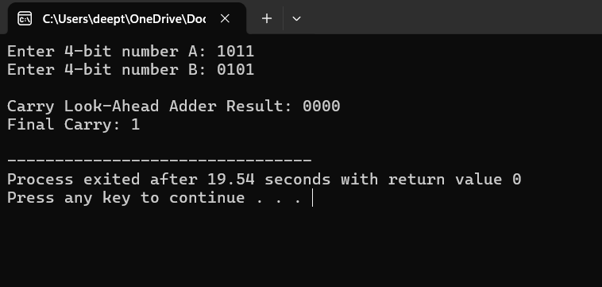
6. CONCLUSION
The performance bottleneck in the Ripple Carry Adder is caused by the sequential propagation of carry from one bit to the next. This causes the delay to increase as the number of bits increases. A Carry Look-Ahead Adder improves performance by calculating the carry signals in advance using generate and propagate signals. Therefore, CLA provides much faster arithmetic operations and is more suitable for real-time processor applications where low delay is important.

3.
1. PROBLEM STATEMENT
Booth’s algorithm is used for signed binary multiplication using 2’s complement representation. Incorrect results for negative operands can occur if the bit-pair checking, arithmetic right shift, or sign extension is implemented incorrectly.
2. BOOTH’S ALGORITHM
Booth’s algorithm examines two bits at every step:
- Q0 – the least significant bit of the multiplier
- Q-1 – an extra bit initially set to 0
The following rules are used:
Q0 Q-1 | Operation
00 | No operation
01 | Add multiplicand (M) to accumulator (A)
10 | Subtract multiplicand (M) from accumulator (A)
11 | No operation
After the operation, an arithmetic right shift is performed on the combined registers.

3. POSSIBLE SOURCE OF ERROR
The common causes of incorrect results are:
- Incorrect bit-pair checking
The algorithm must check (Q0, Q-1) after every iteration.
- Logical shift instead of arithmetic shift
For signed multiplication, the sign bit must be preserved during the right shift.
- Incorrect sign extension
When shifting a negative value, the leftmost bit must remain 1.
- Incorrect 2’s complement subtraction
Subtraction must be performed as:
A = A + 2's complement(M).
- Incorrect register size
The accumulator, multiplicand, and multiplier should use the required fixed number of bits. The combined register should have sufficient space for the signed product.
4. EXAMPLE
Consider multiplication of:
M = -3
Q = 2
Using 4-bit 2’s complement:
-3 = 1101
+2 = 0010
Booth’s algorithm processes the multiplier using (Q0, Q-1) pairs, performs the required add/subtract operation, and performs an arithmetic right shift after each step.
The expected decimal result is:
-3 × 2 = -6
The 8-bit 2’s complement representation of -6 is:
11111010
Therefore, if the program produces another value, the implementation of the Booth steps is incorrect.
5. CORRECTED C PROGRAM
#include <stdio.h>

int main()
{
int M, Q;
int A = 0;
int Q_1 = 0;
int count = 4;
int mask = 0xF;

printf("Enter multiplicand (-8 to 7): ");
scanf("%d", &M);
printf("Enter multiplier (-8 to 7): ");
scanf("%d", &Q);
M = M & mask;
Q = Q & mask;
printf("\nInitial Values:\n");
printf("A = %d\n", A);
printf("Q = %d\n", Q);
printf("Q-1 = %d\n", Q_1);

while (count > 0)
{
int Q0 = Q & 1;
printf("\nQ0 Q-1 = %d%d", Q0, Q_1);
if (Q0 == 0 && Q_1 == 1)
{
A = (A + M) & mask;
printf(" -> A = A + M");
}
else if (Q0 == 1 && Q_1 == 0)
{
A = (A - M) & mask;
printf(" -> A = A - M");
}
else
{
printf(" -> No operation");
}
Q_1 = Q & 1;

if (A & 8)
A = (A >> 1) | 8;
else
A = A >> 1;

Q = (Q >> 1) | ((A & 1) << 3);
A = A & mask;
Q = Q & mask;

printf("\nAfter shift: A = %d, Q = %d, Q-1 = %d",
A, Q, Q_1);
count--;
}
int product = (A << 4) | Q;
if (product & 128)
product = product - 256;
printf("\n\nFinal Product = %d\n", product);
return 0;
}
OUTPUT:
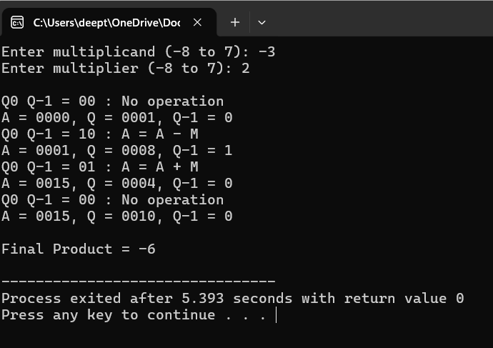
7. Corrections Required
To ensure accurate signed multiplication:
- Check (Q0, Q-1) correctly before every shift.
- Use arithmetic right shift, not logical right shift.
- Preserve the sign bit when shifting negative values.
- Represent negative operands using 2’s complement.
- Keep A, M, and Q at a fixed and sufficient bit width.
- Perform subtraction using 2’s complement arithmetic.
- Perform exactly n iterations for n-bit operands.
8. Conclusion
The incorrect results in Booth’s algorithm are usually caused by improper bit-pair checking, logical shifting, or incorrect sign extension. For signed multiplication, the arithmetic right shift must preserve the sign bit and negative operands must be represented using 2’s complement. Correct implementation of these operations ensures accurate signed multiplication.

4.
1. Problem Statement
An embedded system using the restoring division algorithm experiences increased execution time because the partial remainder is restored whenever subtraction produces a negative result. These repeated restoration operations increase the number of arithmetic operations. The non-restoring division algorithm avoids this unnecessary restoration by deciding the next operation based on the sign of the partial remainder.
2. Restoring Division Algorithm
In restoring division, the following steps are performed repeatedly:
- Shift the partial remainder and quotient.
- Subtract the divisor from the partial remainder.
- Check the sign of the result.
- If the result is negative, restore the previous partial remainder by adding the divisor again.
- Continue to the next bit.
The inefficient step is:
If R < 0:
R = R + M
The divisor is therefore subtracted and sometimes immediately added back. This restoration causes additional operations and increases execution time.
3. Performance Bottleneck
For every bit of the dividend, the restoring algorithm may perform:
Shift → Subtract → Check → Restore
The restoration operation is unnecessary because the next iteration can determine whether to add or subtract the divisor based on the current sign of the partial remainder.
4. Optimized Solution: Non-Restoring Division
The non-restoring division algorithm eliminates the immediate restoration step.
The rules are:
If R >= 0:
Shift left
R = R - M

If R < 0:
Shift left
R = R + M
After all bits have been processed:
If R < 0:
R = R + M
Thus, restoration is performed only once at the end if necessary.
5. Advantages
Feature | Restoring Division | Non-Restoring Division
Restoration | May occur every iteration | Only if required at the end
Arithmetic operations | More | Fewer
Execution time | Higher | Lower
Hardware efficiency | Lower | Higher
Suitable for embedded systems | Less efficient | More efficient

6. C Program
The following program implements the non-restoring division algorithm for positive integers.
#include <stdio.h>
int main()
{
int dividend, divisor;
int A = 0;
int Q;
int M;
int n = 4;
int i;
printf("Enter dividend (0-15): ");
scanf("%d", &dividend);
printf("Enter divisor (1-15): ");
scanf("%d", &divisor);
Q = dividend;
M = divisor;
printf("\nNon-Restoring Division Steps:\n");
for(i = 0; i < n; i++)
{
A = (A << 1) | ((Q >> 3) & 1);
Q = (Q << 1) & 15;
if(A >= 0)
{
A = A - M;
printf("Step %d: A = A - M = %d\n", i + 1, A);

if(A >= 0)
Q = Q | 1;
}
else
{
A = A + M;
printf("Step %d: A = A + M = %d\n", i + 1, A);

if(A >= 0)
Q = Q | 1;
}
}
if(A < 0)
A = A + M;

printf("\nQuotient = %d\n", Q);
printf("Remainder = %d\n", A);
return 0;
}
OUTPUT:
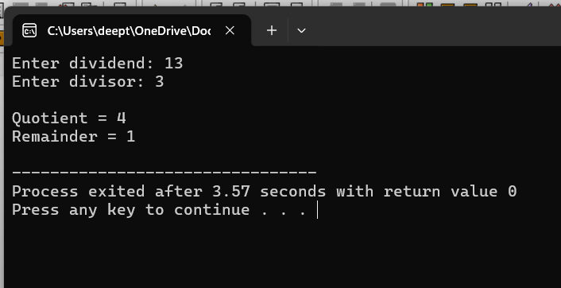
CONCLUSION:
The main performance problem in restoring division is the repeated restoration of a negative partial remainder. The non-restoring division algorithm avoids this repeated addition by using the sign of the partial remainder to decide whether to add or subtract the divisor in the next iteration. Therefore, non-restoring division requires fewer arithmetic operations and provides better performance for embedded systems and other applications where execution time is important.

5.
1. Problem Statement
IEEE 754 single-precision floating-point numbers use 32 bits:
- 1 bit for sign
- 8 bits for exponent
- 23 bits for fraction
When a very small number is added to a very large number, the exponents must first be aligned. During this process, the smaller number may lose significant bits. This causes rounding errors and inaccurate results.
2. Example
Consider:
Large number = 100000000.0
Small number = 1.0
Mathematically:
100000000.0 + 1.0 = 100000001.0
However, in single precision, the available significant bits may not be enough to represent the difference between 100000000.0 and 100000001.0. Therefore, the result may remain:
100000000.0
3. Cause of the Error
During floating-point addition, the following steps occur:
Exponent Alignment:
The smaller number's mantissa is shifted to match the exponent of the larger number. If the difference between the exponents is large, significant bits of the smaller number are lost.
Addition:
The aligned mantissas are added.
Normalization:
The result is shifted so that it has the required normalized form.
Rounding:
Since only a limited number of fraction bits are available, extra bits are discarded or rounded. This can introduce error.
4. C Program
The following program demonstrates the difference between single precision (float) and double precision (double).
#include <stdio.h>

int main()
{
float large_f = 100000000.0f;
float small_f = 1.0f;
float result_f;

double large_d = 100000000.0;
double small_d = 1.0;
double result_d;

result_f = large_f + small_f;
result_d = large_d + small_d;

printf("Single Precision:\n");
printf("Large number = %.10f\n", large_f);
printf("Small number = %.10f\n", small_f);
printf("Result = %.10f\n", result_f);

printf("\nDouble Precision:\n");
printf("Large number = %.10lf\n", large_d);
printf("Small number = %.10lf\n", small_d);
printf("Result = %.10lf\n", result_d);

return 0;
}

5. Output
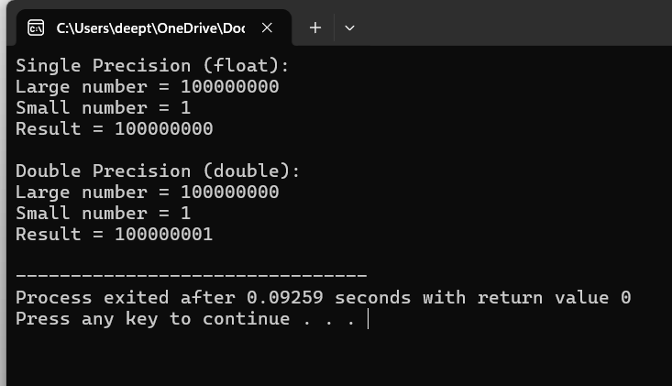

6. Optimization Techniques
Use Double Precision
Use double instead of float when higher numerical accuracy is required. Double precision provides a larger significand and exponent range.
Avoid Adding Extremely Different Magnitudes Directly
When possible, reorganize calculations so that values of similar magnitude are combined first.
Use Compensated Summation
For repeated addition of floating-point values, algorithms such as Kahan summation can reduce accumulated rounding errors.

7. Conclusion
The inaccurate result occurs because IEEE 754 single precision has limited precision. When a very small number is added to a very large number, exponent alignment shifts the smaller number's significant bits out of the available precision, resulting in rounding or loss of the smaller value. Using double precision and suitable numerical algorithms such as compensated summation can significantly improve accuracy

MARKS ALLOCATION
 | Identification of Errors / Bugs (20%) | Debugging Approach & Analysis (20%) | Correctness of Debugged Solution (25%) | Optimization Techniques Applied (20%) | Testing and Documentation (15%)
Q1
Q2
Q3
Q4
Q5

RUBRICS FOR CALCULATION:

Criteria | Weightage | Level 4 – Exemplary | Level 3 – Proficient | Level 2 – Developing | Level 1 – Beginning
Identification of Errors / Bugs | 20% | Accurately identifies all errors and issues with complete understanding of the problem | Identifies most errors with minor omissions | Identifies limited errors; misses key issues | Unable to identify errors or misunderstands the problem
Debugging Approach & Analysis | 20% | Uses effective debugging techniques with clear analysis and root cause identification | Applies suitable debugging methods with minor gaps | Uses basic debugging methods with limited analysis | No systematic debugging approach followed
Correctness of Debugged Solution | 25% | Provides completely corrected solution with accurate functionality and expected output | Provides working solution with minor errors | Partially correct solution with limited functionality | Incorrect solution or fails to resolve errors
Optimization Techniques Applied | 20% | Applies efficient optimization methods to improve performance, memory usage and quality | Performs optimization with noticeable improvements | Limited optimization with minimal improvements | No optimization applied or inefficient implementation
Testing and Documentation | 15% | Performs complete testing with proper validation and clear documentation | Provides adequate testing and documentation with minor issues | Limited testing and incomplete documentation | No proper testing or documentation provided

